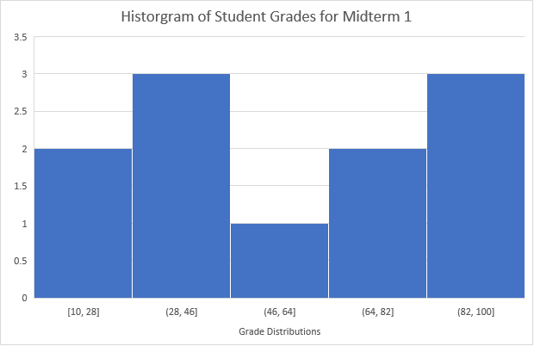

|  |  |  |  |
| --- | --- | --- | --- |
| Interval | Width | Height | Percent |
| 10-28 | .2 | 2 | 36 |
| 28-46 | 18 | 3 |  |
| 46-64 | 18 | 1 |  |
| 64-82 | 18 | 2 |  |
| 82-100 | 18 | 3 |  |